
IP Communications Applications for Business Advantage

Metreos CallMonitor
User Guide
Metreos Communications Environment 2.1

Copyright © 2005 Metreos Corporation
All Rights Reserved

Proprietary and Confidential

Overview
Metreos CallMonitor® allows a monitoring agent to use a standard PSTN telephone to call into a remote site and monitor conversations at random.

As the monitoring agent, your site administrator will have already designated and configured a group or groups of phones available to be monitored, along with the associated phone number and PIN access and authentication numbers.

Your administrator will have supplied you with phone number you will dial in order to begin monitoring a phone using Metreos CallMonitor, and the PIN you will use to authenticate.

Figure 1 illustrates the usage flow of an agent monitoring a single call.

.
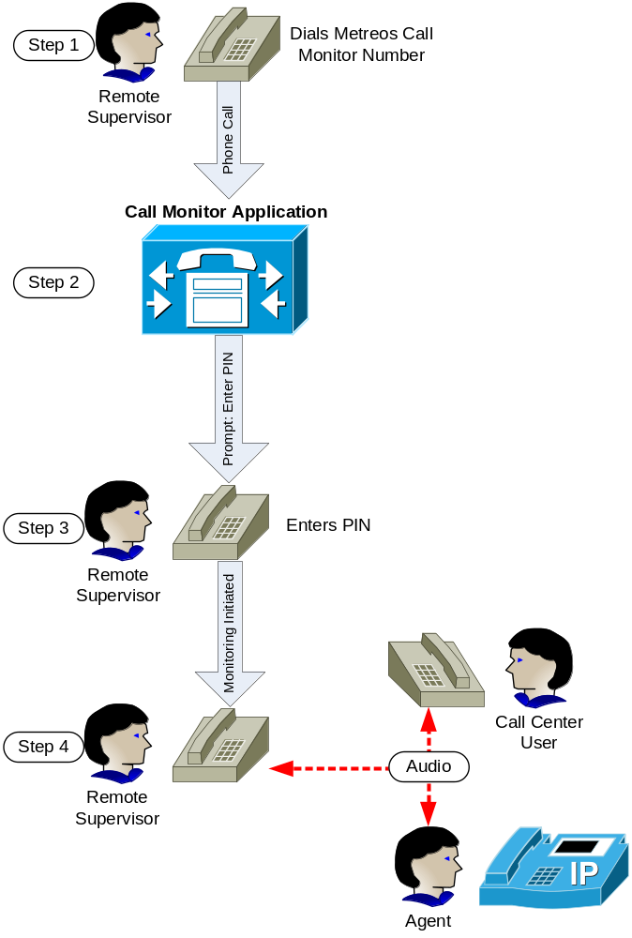
Figure 1: CallMonitor Usage Flow

CallMonitor Usage Information

No Active Calls
If there are no active calls available for monitoring when the remote supervisor calls in, CallMonitor will inform the remote supervisor of that condition, and hang up. This is not an error condition.

Prompt | There are no active calls to monitor in this group.

Authentication
Once a PIN number has been entered and failed a number of times as configured by the site administrator, CallMonitor will forcibly hang up.

Prompt | Authentication failed, goodbye.

Invalid Configuration
It is possible for CallMonitor to be configured such that when a conversation is chosen to monitor, the application does not have all the information it needs to monitor that particular conversation. In this case an error message will play and the application will hang up. Please contact your site administrator for resolution of this error..

Prompt | There are no devices associated with this access number.

General Application Error
If a system-level error occurs, the application will advise you to try again later. Should this error occur repeatedly, contact your site administrator for resolution.

Prompt | All monitoring attempts have failed; please try your call again later. If this message persists, please contact the system administrator.

